**THE LION**

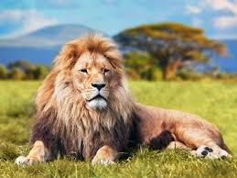

The lion is one of the largest cats in the world. The lion is a mammal. A mammal means that it has warm blood and fur, the lion eats meat because it is a carnivore.

The lion has a large and hairy mane to be able to scare other animals. The lion can run very fast to be able to follow his prey the lions lives in groups called herds

1. A. it has B. had c. to have
2. A. eats B. ate c. i Will eat
3. A. run B. ran c. i Will run
4. A. lives B. lived c. Will live

PARTE 3

1. in the math class that you used?

a. a calculator

b. not used, a periodic table?

c. no better a laso

2. My dad is going to buy me a colored suitcase?

a.red, didn't you want?

b. dwelling

c. same as your sister's

3. My cell phone is damaged, what can I do?

a. buy you another

b. do stuff

c. buy headphones

4.Carlos's aunt, lives very far and can't make it to the appointment, what can she do?

a. Aunt, are you canceling the appointment?

b. she is going to the house

c. I sleep

5. Do my shoes match my outfit?

a.no thanks i don't need it

b. Of course, friend, they look great on you.

c. you will always be brilliant